Scottish Cardiovascular Forum – Saturday 2nd February 2019
Preliminary programme

09.00: Arrival, registration, coffee

09.30: Introduction
Prof Ian Megson, UHI
Prof Clive Mulholland (if available)

10.00: Session 1: Chair: Dr James Cobley
Keynote lecture
Prof Damien Bailey, University of South Wales
Life without oxygen! cerebrovascular modulation of blood flow to the oxygen-starved brain

11.00: Break

11.15: Session 2: Chair: Prof Steve Leslie
3 minute PhD pitches - first and second year students only (+ max 2 questions) (£100 prize)

12.00: Lunch and Poster session

13.30: Session 3: Chair: TBC
Rodger Wadsworth Prize: Final year PhD student presentations (Judged - £300 prize)
(approx. 10 min presentations + 5 min Qs)

14.30: Session 3: Chair: Dr David Muggeridge
Oral communications (10 min + 5 min Q’s)

15:30: Tea, coffee, posters

16.00: Session 4: Chair: TBC
Oral communications (10 min + 5 min Q’s)

16.30: Summing up, prize-giving
Prof Ian Megson
Prizes – Rodger Wadsworth Prize - £300 | 3 minute PhD - £100 | Oral - £150 | Poster - £75 |

16.45: Close and networking

Trains:
Aberdeen – 17:14, 18:13
Edinburgh & Glasgow – 17:28, 18:41

Meeting location:

The Centre for Health Science
Old Perth Road
Inverness

(Other maps of the area are also available at: http://www.centreforhealthscience.com/Find-Us-g.asp)

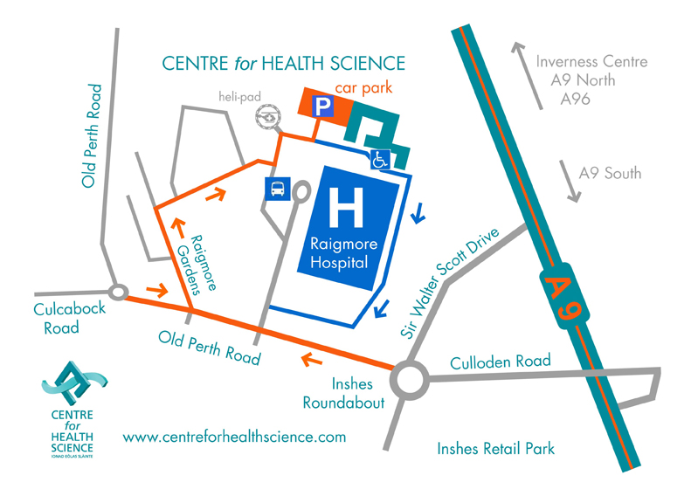

Accommodation close to Centre for Health Science, Old Perth Road, Inverness,
IV2 3JH

Premier Inn – Inverness East Hotel
Beechwood Business Park
Inverness
IV2 3BW
Website: www.premierinn.com

Premier Inn
Inverness Centre (Millburn Road) Hotel
Millburn Road
Inverness
IV2 3QX
Website: www.premierinn.com

UHI Student Accommodation
7 Inverness Campus
Inverness
IV2 5NA
Email: diane.abernethy@uhi.ac.uk

The Kingsmills Hotel
Culcabock Road
Inverness
IV2 3LP
Tel: 01463 237 166
Website: www.kingsmillshotel.com

Jurys Inn Inverness
Millburn Road
Inverness
IV2 3TR
Tel: 0161 774 2986
Email: jurysinninverness@jurysinns.com
Website: www.jurysinns.com/hotels/inverness

Thanks to our sponsors for the event







