 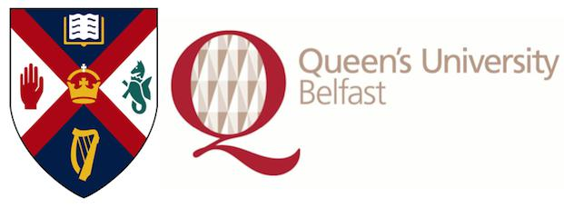

**Scottish Cardiovascular Forum**

**19th Annual Meeting**

**Saturday 6th February 2016**

The Wellcome-Wolfson Institute for Experimental Medicine

Queen’s University Belfast, Northern Ireland

Organisers: Dr David Bell and Dr Chris Johnson (QUB)

You are cordially invited to attend this one day meeting for those with an interest in cardiac and vascular research – both clinical and basic science.

**Abstracts:** Form Attached (please see appendix 1 below)

**Abstract Submission Deadline:** Friday January 8th 2016.

We particularly welcome submissions from early career researchers including PhD and MD students and post-doctoral researchers, and final year BSc and intercalating medical students.

The purpose of the SCF is to act as a discussion forum for researchers in Scotland and Northern Ireland studying the cardiovascular system. Therefore, the meeting welcomes presentations **of studies in progress and will accept abstracts that have been presented previously**.

**Roger Wadsworth Prize**

Roger Wadsworth Prize - most significant contribution to cardiovascular research by a final year PhD student.

To be awarded for the third time at SCF 2016.

Delegates wishing their abstracts to be considered for the Roger Wadsworth award should complete the application form (please see appendix 2- separate email attachment) and should meet the following criteria:

1. Students should be in the final year of their PhD.

2. Students should submit a summary of why their research has made a significant contribution to the cardiovascular research community (500 words maximum).

3. Students should deliver a 10 minute oral presentation (not a poster).

4. A short supporting statement from the supervisor should be submitted with the application.

**Registration:** (online registration will open on 1st November 2015 and close on the morning of the event- however early registration would be very much appreciated to assist with catering arrangements).

**URL** [http://www.eventbrite.com/e/scottish-cardiovascular-forum-19th-annual-meeting-tickets-18601230782](http://www.eventbrite.com/e/scottish-cardiovascular-forum-19th-annual-meeting-tickets-18601230782?aff=utm_source%3Deb_email%26utm_medium%3Demail%26utm_campaign%3Dnew_event_email?utm_term=eventurl_text)

**Registration Cost:** £25 (£10 for students) – this includes payment handling fee

Scottish Cardiovascular Forum 2016 Abstract template Appendix 1

**Title: Boldface type, Arial, font size 12**

**Presenting author1**, coauthor2, coauthor1, coauthor1, coauthor1

*1: Affiliation presenting author & co-authors*

*2: Affiliation co-author*

INSTRUCTIONS:

Please replace the text in the boxes, retaining the text formatting.

Abstract body: Arial font size 12.

Please do not exceed one page, and do not modify this document size, line spacing, etc.

Please save the abstract with a filename matching the surname of the presenting author and email abstracts to [d.bell@qub.ac.uk](mailto:d.bell@qub.ac.uk) in either Word (.doc) or portable document format (.pdf) format.

All correspondence will be sent to the email address from which the abstract is sent. Notification of selection for oral / poster presentation will be sent in mid-January 2016.

If you have a preference for oral or poster presentation please indicate this in the email message to which you attach the completed abstract. Please also indicate whether or not the presenting author is a current research student.