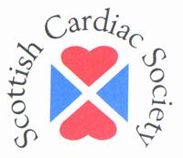 MEETING REGISTRATION FORM

SCOTTISH CARDIAC SOCIETY SPRING MEETING
DOUBLETREE BY HILTON, DUNBLANE HYDRO
TUESDAY 28 APRIL 2015

TITLE FIRST NAME SURNAME

JOB TITLE

ADDRESS

EMAIL

TELEPHONE

DIETARY REQUIREMENTS

 | Cost | Tick
Scottish Cardiac Society Member | FREE
Non-member:  Doctor (Cardiologist, Surgeon, Physician, Specialist Registrar etc.) | £50
Non-member:  Allied Health Professionals | £30

PLEASE MAKE CHEQUES PAYABLE TO ‘SCOTTISH CARDIAC SOCIETY’ AND POST TO:

Kate Curry
Society Administrator
Royal College of Physicians of Edinburgh
9 Queen Street
Edinburgh
EH2 1JQ

TEL: 0131 247 3687, FAX: 0131 220 4393, Email: SCS.admin@rcpe.ac.uk

