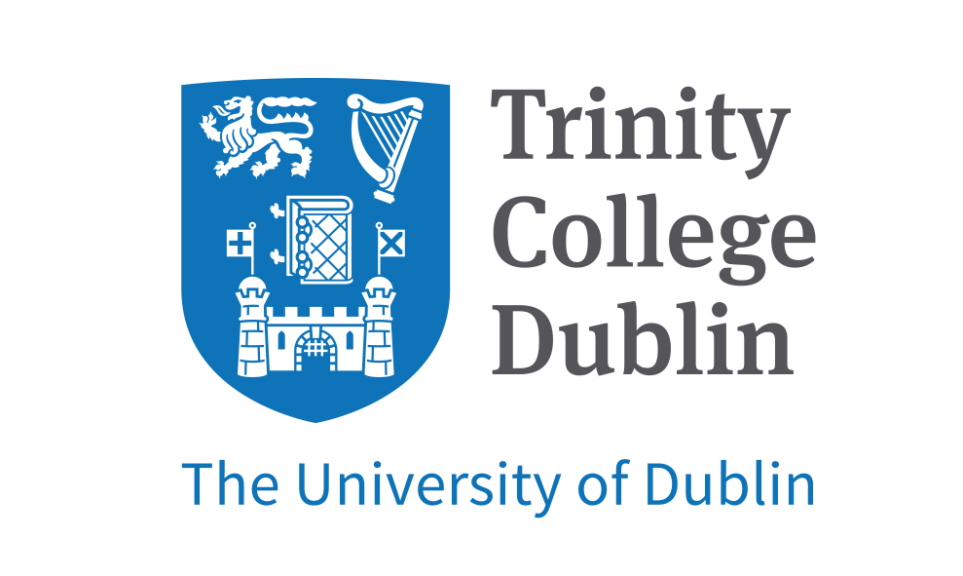

**Scottish Cardiovascular Forum**

**21st Annual Meeting**

**Saturday 3th February 2018**

Trinity Biomedical Science Institute

Trinity College Dublin, Ireland

Organisers: Dr Paul Spiers, Dr Margaret Lucitt and Dr Martina Hennessy Johnson (QUB)

You are cordially invited to attend this one day meeting for those with an interest in cardiac and vascular research – both clinical and basic science.

**Abstracts:** Form Attached (please see appendix 1 below)

**Abstract Submission Deadline:** Friday January 12th 2018.

We particularly welcome submissions from early career researchers including PhD and MD students and post-doctoral researchers, and final year BSc and intercalating medical students.

The purpose of the SCF is to act as a national discussion forum for researchers in studying the cardiovascular system. Therefore, the meeting welcomes presentations **of studies in progress and will accept abstracts that have been presented previously**.

**Authors should indicate whether they wish their abstract to be considered for publication in Heart**

**Roger Wadsworth Prize**

Roger Wadsworth Prize - most significant contribution to cardiovascular research by a final year PhD student.

Will be awarded again at SCF 2018.

Delegates wishing their abstracts to be considered for the Roger Wadsworth award should complete the application form (please see appendix 2- separate email attachment) and should meet the following criteria:

1. Students should be in the final year of their PhD.

2. Students should submit a summary of why their research has made a significant contribution to the cardiovascular research community (500 words maximum).

3. Students should deliver a 10-minute oral presentation (not a poster).

4. A short supporting statement from the supervisor should be submitted with the application.

**Registration:** (online registration - details to follow).

**Registration Fee:** €25 (€10 for students) + Everbrite fee

Scottish Cardiovascular Forum 2018 Abstract template Appendix 1

**Title: Boldface type, Arial, font size 12**

**Presenting author1**, coauthor2, coauthor1, coauthor1, coauthor1

*1: Affiliation presenting author & coauthors*

*2: Affiliation coauthor*

INSTRUCTIONS:

Please replace the text in the boxes, retaining the text formatting.

Abstract body: Arial font size 12.

Please do not exceed one page, and do not modify this document size, line spacing, etc.

Please save the abstract with a filename matching the surname of the presenting author and email abstracts to paul.spiers@tcd.ie in either Word (.doc) or portable document format (.pdf) format.

All correspondence will be sent to the email address from which the abstract is sent. Notification of selection for oral / poster presentation will be sent in mid-January 2018.

If have a preference for oral or poster presentation please indicate this in the email message to which you attach the completed abstract.

**Please tick if you wish to have your abstract considered for publication in Heart**